The Motor Effect
Learning Outcomes
- I know what happens to a current carrying conductor is in a magnetic field
- I can use Fleming’s Left Hand Rule
- I can describe how simple DC electric motors work
- I know how to increase the size of the force
- I know what happens to a charged particle moving in a magnetic field

The Motor Effect
What happens when a current carrying conductor (wire) is within a magnetic field?
current
N
S

Five Easy Pieces:
- The …………… flows
- This creates a ………….. field around the wire.
- This magnetic field will …….. and ……… against the permanent magnetic field
- The wire will experience a resultant ………
- The …………. of the force is given by Fleming’s Left Hand Rule

Fleming’s Left Hand Rule
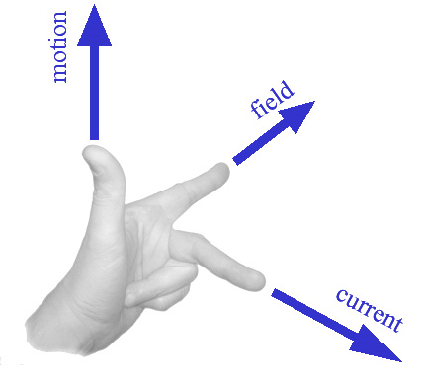
- The First finger is the Field
- The seCond finger is the Current
- The thuMb is the Motion
The Motor effect is used is all electric motor and other devices such as the rail gun!
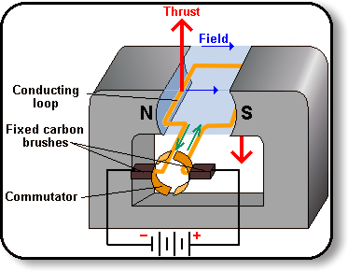
How do increase the force on an electric motor:
- Increase the ……………
- Increase the strength of the ……………. field
- More …………… in the coil
What happens when a moving charge (eg an electron) travels at 90º to a magnetic field?
Electron
Magnetic Field

- A moving charge, in a Magnetic Field will experience a …………………
- The direction of the force is given by Fleming’s …………. Hand Rule.
- The force on the charge causes it to change its ………………………
- This then changes the direction of the ……………………..., which then changes the direction of the force.
- Since the direction of motion of the charge and the force on it are at …………….. angles, the charge will move in a …………………. path!

This effect is used in particle accelerators such as the Large Hadron Collider.

What happens to a moving charge (eg an electron) travelling parallel to a magnetic field?
Electron
Magnetic Field

There is ……… force.
A moving charge in a magnetic field will experience a ……………… only if it is moving ……………….. to the magnetic field
(or at least if a component of its velocity is perpendicular to the field).

Homework; P 211 Q 1 & 3; P 226 Q 4.
Optional Extension Task – Research “Rail guns”!
Investigating the Motor Effect
Research Question:
What is the relationship between Current and Force for a current carrying conductor in a magnetic field?
N
S
S
Tare the top pan balance.
The force between the magnetic field and the wire will now be recorded on the top pan balance.

